**Assignment 3**

**// Q1. print numbers from 1 to 10**

    int no = 1;

    while (no<11)

    {

        printf("Your no is %d\n", no);

        no++;

    }

**Output:**

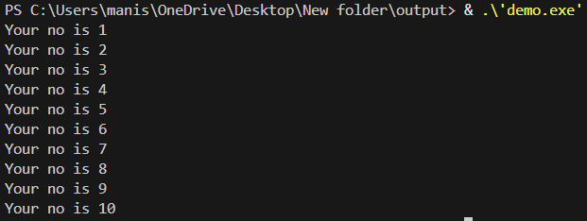

**//Q2. Print table for the given number**

    int no = 1;

    int table = 4;

    int multiplication;

    while (no<11)

    {

        multiplication = no * table;

        printf("Table : %d * %d = %d \n", table, no, multiplication);

        no++;

    }

**Output:**

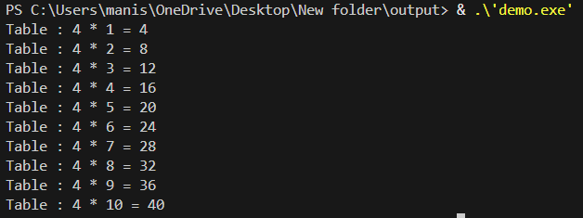

**// Q3. Calculate sum of numbers in the given range**

    int num1 = 1;

    int num2 = 5;

    int sum = 0;

    while (num1 <= num2)

    {

        sum += num1;

        num1++;

    }

    printf("sum is: %d", sum);

**Output:**



**// Q4. Check no is prime or not.**

    int no = 13;

    int status = 0;

    int i =2;

    while (i<no)

    {

        if (no%i==0)

        {

            status = 1;

            break;

        }

        i++;

    }

    if (no<2){

        printf("No %d is not a prime no", no);

    } else if (status == 0){

            printf("No %d is a prime no", no);

    } else {

        printf("No %d is not a prime no", no);

    }

**Output:**

**// Q5. Check number is Armstrong or not?**

    int no = 153;

    int original_no = no;

    int temp = no;

    int sum = 0;

    int digits = 0;

    while (temp>0)

    {

        temp = temp/10;

        digits++;

    }

    temp = no;

    int digit = 1;

    while (temp>0)

    {

        digit = temp % 10;

        int i = 0;

        int power =1;

        while (i<digits)

        {

            power = power * digit;

            i++;

        }

        sum += power;

        temp = temp/10;

    }

    if (original_no==sum)

    {

        printf("%d is armstrong no", sum);

    } else

    {

        printf("%d is not armstrong no", sum);

    }

**Output:**



**// Q6. Check number is perfect or not.**

    int no = 28;

    int temp = no;

    int i = 1;

    int reminder = 0;

    int sum = 0;

    while (i <= temp / 2) {

        reminder = temp % i;

        if (reminder == 0) {

            sum += i;

        }

        i++;

    }

    if (no == sum) {

        printf("%d is a perfect\n", no);

    } else {

        printf("%d is not perfect\n", no);

    }

**Output:**



**// Q7. find factorial or number**

    int no =5;

    int factorial = 1;

    while (no>=1)

    {

        factorial = factorial * no;

        no--;

    }

    printf("Factorial of no: %d", factorial);

**Output:**



**// Q8. Check number is strong or not.**

    int no = 145;

    int temp = no;

    int digit = 0;

    int sum = 0;

    while (temp > 0) {

        digit = temp % 10;

        int i = 1;

        int factorial = 1;

        while (i <= digit) {

            factorial *= i;

            i++;

        }

        sum += factorial;

        temp /= 10;

    }

    if (no == sum) {

        printf("%d is a Strong Number\n", no);

    } else {

        printf("%d is not a Strong Number\n", no);

    }

**Output:**



**// Q9. Check the no is Palindrome or not**

    int no = 151;

    int temp = no;

    int remember = 0;

    int reverse = 0;

    while (temp>0)

    {

        remember = temp% 10;

        reverse = reverse *10 + remember;

        temp = temp/10;

    }

    temp = no;

    if (no == reverse){

        printf("no %d is a Palimdrome", no);

    } else {

        printf("no %d is not a Palimdrome", no);

    }

**Output:**

**// Q10. Add the (first and last) digit of the given number**

    int no = 156;

    int temp = no;

    int remember = 0;

    int reverse = 0;

    int fistdigit, lastdigit;

    while (temp>0)

    {

        remember = temp% 10;

        reverse = reverse *10 + remember;

        temp = temp/10;

    }

    fistdigit = reverse%10;

    lastdigit = no%10;

    int sum_of_fist_and_last = fistdigit + lastdigit;

    printf("Sum of first and last digit is: %d + %d = %d", fistdigit, lastdigit, sum_of_fist_and_last);

**Output:**

